**HOW TO INTEGRATE ONLYOFFICE WITH OWNCLOUD**

**BY STEPHEN FOSU**

ONLYOFFICE Document Server is an online office suite comprising viewers and editors for texts, spreadsheets and presentations, fully compatible with Office Open XML formats: .docx, .xlsx, .pptx and enabling collaborative editing in real time.

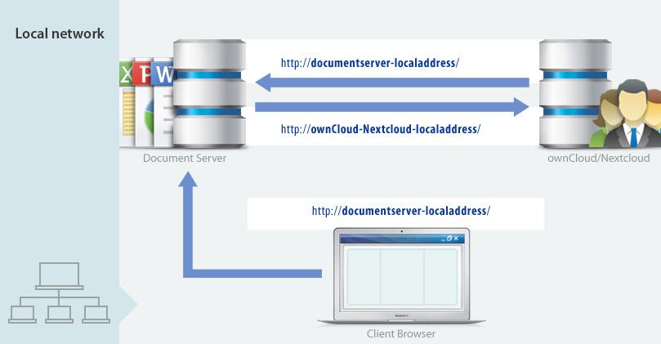



**INSTALLING ONLYOFFICE DOCUMENT SERVER**

root@snet[~]# sudo apt install postgresql

root@snet[~]# sudo -u postgres psql -c "CREATE DATABASE onlyoffice;"

root@snet[~]# sudo -u postgres psql -c "CREATE USER onlyoffice WITH password 'onlyoffice';"

root@snet[~]# sudo -u postgres psql -c "GRANT ALL privileges ON DATABASE onlyoffice TO onlyoffice;"

root@snet[~]# curl -sL https://deb.nodesource.com/setup_6.x | sudo -E bash -

root@snet[~]# sudo apt install nodejs

root@snet[~]# sudo apt install redis-server rabbitmq-server

root@snet[~]# systemctl status redis-server

root@snet[~]# systemctl status rabbitmq-server

**INSTALL ONLYOFFICE DOCUMENT SERVER**

root@snet[~]# echo "deb http://download.onlyoffice.com/repo/debian squeeze main" | sudo tee /etc/apt/sources.list.d/onlyoffice.list

root@snet[~]# sudo apt-key adv --keyserver hkp://keyserver.ubuntu.com:80 --recv-keys CB2DE8E5

root@snet[~]# sudo apt update

root@snet[~]# sudo apt install onlyoffice-documentserver

**ENABLING HTTPS USING LET’S ENCRYPT TLS CERTIFICATE**

root@snet[~]# sudo nano /etc/nginx/conf.d/onlyoffice-documentserver.conf

**Change the configuration like below. Don’t forget to set an A record for onlyoffice.your-domain.com.**

include /etc/nginx/includes/onlyoffice-http.conf;

server {

listen 0.0.0.0:80;

listen [::]:80 default_server;

server_name office.snetgh.net;

server_tokens off;

include /etc/nginx/includes/onlyoffice-documentserver-*.conf;

location ~ /.well-known/acme-challenge {

root /var/www/onlyoffice/;

allow all;

}

}

root@snet[~]# sudo systemctl reload nginx

**THEN INSTALL CERTBOT (LET’S ENCRYPT) CLIENT.**

root@snet[~]# sudo apt install letsencrypt

**Change the domain to A record and email**

root@snet[~]# sudo letsencrypt certonly --webroot --agree-tos –snetgh@gmail.com -d office.snetgh.net -w /var/www/onlyoffice/

root@snet[~]# sudo nano /etc/nginx/conf.d/onlyoffice-documentserver.conf

**Delete everything in that file and paste the following text into the file. Change the red text accordingly.**

include /etc/nginx/includes/onlyoffice-http.conf;

## Normal HTTP host

server {

listen 0.0.0.0:80;

listen [::]:80 default_server;

server_name office.snetgh.net;

server_tokens off;

## Redirects all traffic to the HTTPS host

root /nowhere; ## root doesn't have to be a valid path since we are redirecting

rewrite ^ https://$host$request_uri? permanent;

}

#HTTP host for internal services

server {

listen 127.0.0.1:80;

listen [::1]:80;

server_name localhost;

server_tokens off;

include /etc/nginx/includes/onlyoffice-documentserver-common.conf;

include /etc/nginx/includes/onlyoffice-documentserver-docservice.conf;

}

## HTTPS host

server {

listen 0.0.0.0:443 ssl;

listen [::]:443 ssl default_server;

server_name office.snetgh.net;

server_tokens off;

root /usr/share/nginx/html;

ssl_certificate /etc/letsencrypt/live/office.snetgh.net/fullchain.pem;

ssl_certificate_key /etc/letsencrypt/live/office.snetgh.net/privkey.pem;

# modern configuration. tweak to your needs.

ssl_protocols TLSv1.2;

ssl_ciphers 'ECDHE-ECDSA-AES256-GCM-SHA384:ECDHE-RSA-AES256-GCM-SHA384:ECDHE-ECDSA-CHACHA20-POLY1305:ECDHE-RSA-CHACHA20-POLY1305:ECDHE-ECDSA-AES128-GCM-SHA256:ECDHE-RSA-AES128-GCM-SHA256:ECDHE-ECDSA-AES256-SHA384:ECDHE-RSA-AES256-SHA384:ECDHE-ECDSA-AES128-SHA256:ECDHE-RSA-AES128-SHA256';

ssl_prefer_server_ciphers on;

# HSTS (ngx_http_headers_module is required) (15768000 seconds = 6 months)

add_header Strict-Transport-Security max-age=15768000;

ssl_session_cache builtin:1000 shared:SSL:10m;

# add_header X-Frame-Options SAMEORIGIN;

add_header X-Content-Type-Options nosniff;

# ssl_stapling on;

# ssl_stapling_verify on;

# ssl_trusted_certificate /etc/nginx/ssl/stapling.trusted.crt;

# resolver 208.67.222.222 208.67.222.220 valid=300s; # Can change to your DNS resolver if desired

# resolver_timeout 10s;

## [Optional] Generate a stronger DHE parameter:

## cd /etc/ssl/certs

## sudo openssl dhparam -out dhparam.pem 4096

##

#ssl_dhparam {{SSL_DHPARAM_PATH}};

location ~ /.well-known/acme-challenge {

root /var/www/onlyoffice/;

allow all;

}

include /etc/nginx/includes/onlyoffice-documentserver-*.conf;

}

root@snet[~]# sudo nginx -t

root@snet[~]# sudo systemctl reload nginx

**ENABLING OWNCLOUD ONLYOFFICE INTEGRATION APP**

Login to ownCloud as admin and navigate to owncloud market place and install onlyoffice app

Go to OwnCloud, open the page with **Not** enabled apps and click **Enable** for the **ONLYOFFICE** application.

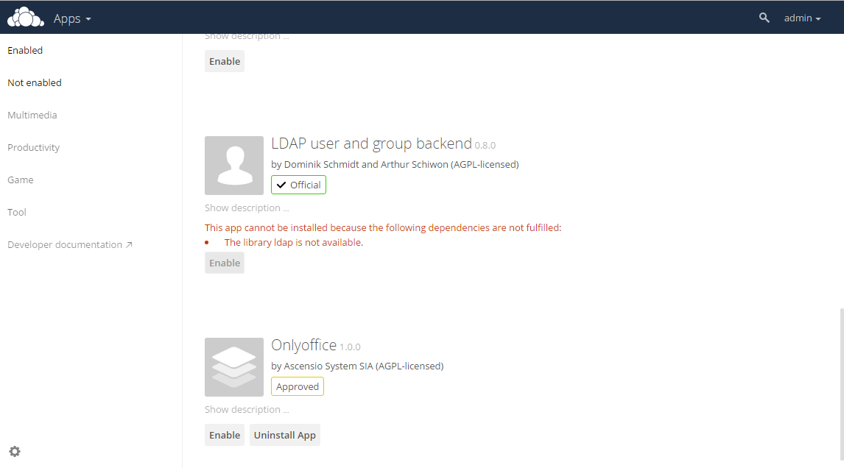

Go to the OwnCloud Admin panel, open the ONLYOFFICE section and enter the address of the server where the ONLYOFFICE Document Server is installed:

https://<documentserver>

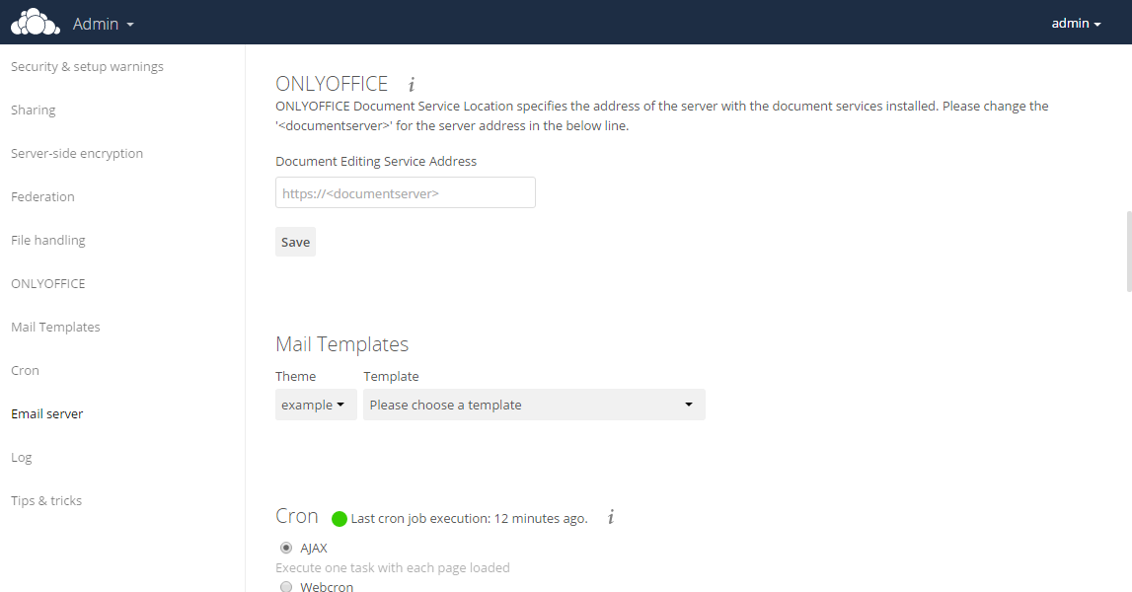

Start editing documents

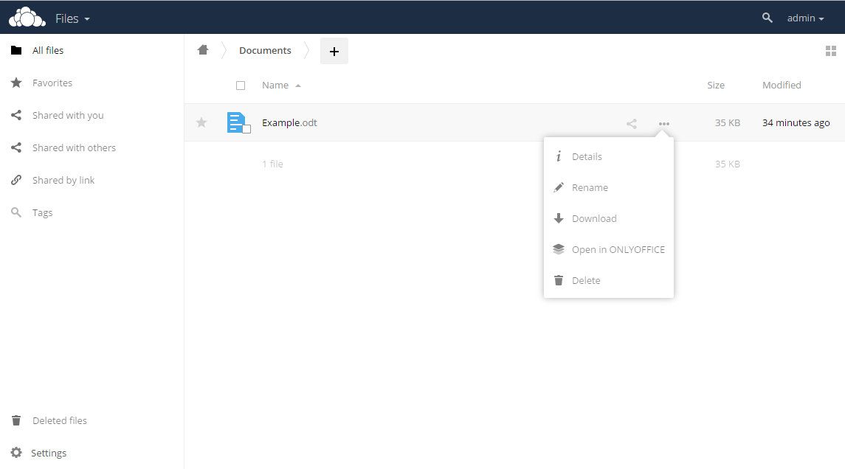

*BY STEPHEN FOSU*